

**Project Woodland**

**Project Charter**

Release : 1.2

Date : 20.07.21

Page **1** of **30**

DOCUMENT CONTROL

DOCUMENT INFORMATION

|  | **Information** |
| --- | --- |
| Document Id | *Project Charter* |
| Document Owner | *Project Board* |
| Issue Date | *TBD* |
| File Name | *Project Charter.docx* |
| Author | *Project Manager* |

DOCUMENT HISTORY

| **Version** | **Issue Date** | **Changes** |
| --- | --- | --- |
| *1.0* | *28.06.2021* | *Initial discussion draft: Sponsor, Board, WG Chairs, DAFM Leads* |
| *1.1* | *09.07.2021* | *Draft with amendments from Project Board and DAFM* |
| *1.2* | *19.07.2021* | *Board approved this version for release* |
|  |  |  |
|  |  |  |
|  |  |  |

Page **2** of **30**

**Contents**

1.0 INTRODUCTION.................................................................................................................................................4 2.0 PROJECT WOODLAND – BACKGROUND & SCOPE.............................................................................................4 2.1 BACKGROUND...............................................................................................................................................4 2.2 DELIMITING PROJECT SCOPE ........................................................................................................................6 2.3 FORESTRY POLICY GROUP (FPG)...................................................................................................................6 2.4 PROJECT OPERATING DEFINITION AND ASSUMPTIONS ...............................................................................8 3.0 ARRANGEMENT OF THE WORK ......................................................................................................................10 3.1 WORKGROUP TERMS OF REFERENCE, SCOPE, OBJECTIVES........................................................................10 3.2 BUSINESS SYSTEMS ANALYSIS & PROCESS .................................................................................................13 3.3 INDEPENDENT REVIEWS – IRELAND, EU AND EUROPE...............................................................................13 4.0 PROJECT COMMUNICATIONS AND REPORTING.............................................................................................14 5.0 GOVERNANCE .................................................................................................................................................15 5.1 ROLE OF THE PROJECT BOARD....................................................................................................................15 5.2 ORGANISATION OF WORKGROUPS ............................................................................................................15 5.3 ROLE OF THE SPONSOR AND PROJECT MANAGER .....................................................................................15 5.4 GOVERNANCE—PROJECT ORGANISATION .................................................................................................15 5.5 GOVERNANCE—PROJECT BOARD STANDARD OPERATING PROCEDURES .................................................17 5.6 GOVERNANCE—WORKING GROUP STANDARD OPERATING PROCEDURES...............................................21 6.0 CHANGE CONTROL PROCESS ..........................................................................................................................24 APPENDICES..........................................................................................................................................................25 1. OVERALL STATUS REPORT ............................................................................................................................25 2. WORKGROUP STATUS REPORT.....................................................................................................................29

Page **3** of **30**

1.0 INTRODUCTION

In standard project management practice, a Project charter would be drawn up at the start of the process, however, given the pace and urgency of the work needed on Project Woodland, substantial work has already been undertaken. This Charter has been prepared to draw those threads together into a single document as well as design a process for future delivery. It draws on documentation generated since the decision to proceed with the project including: the O’Hara Report1, the MacKinnon Report2, workgroup meeting agendas/minutes/notes) and Project Board decisions. To that purpose it looks back to mid March 2021 to document the common understanding of the nature, purpose, organisation and resourcing of Project Woodland.

A Project Charter sets out core operating principles together with a procedural framework in line with the general requirements of professional project practice. It provides a consistent basis for:

• project management/oversight

• delivering and responding to evidenced submissions and recommendations • setting clear expectations

• managing risk

• tracking overall progress

• assuring quality, successful governance and delivery.

2.0 PROJECT WOODLAND – BACKGROUND & SCOPE

2.1 BACKGROUND

Project Woodland (PW) comprises four closely linked workstreams that have been initiated by DAFM following: (1) a review of forestry licensing and associated processes during November 2019 by Jim MacKinnon, and (2) subsequent 2021 analysis and recommendations by Jo O’Hara for implementing MacKinnon. Following the MacKinnon review, and throughout the first half of 2020, there was a significant increase in appeals against licencing decisions. Resultant delays in processing felling licences threatened the timber supply chain and the rate of growth of the backlog increased as a consequence.

The workstreams were established formally as four Workgroups (WG) during Q1 2021, each WG dealing with a workstream designed by O’Hara to implement MacKinnon. The four Workgroups (referred to here as WG1, WG2, WG3 and WG4) address the depth and breadth of the MacKinnon recommendations: (1) WG1 deals with the licencing backlogs, (2) WG2 is formulating future strategy and a national approach to forestry, (3) WG3 is reviewing DAFM forestry organisational development and customer-centric focus, and (4) WG43seeks to improve end-to-end licensing processes.

1 O’Hara, Jo (2021), ‘Implementation of the Mackinnon Report: Advice to the Minister of State for LandUse and Biodiversity on improving the delivery offorestry licensing processes’, FutureArk Ltd

2 MacKinnon, Jim (2019), ‘Review of Approval Processes for Afforestation in Ireland’ 3 WG4 has an important sub-task of understanding licensing processes in other European countries, the legislative/regulatory frameworks for Forestry in Ireland and the role of the EU now and in the future in influencing such processes.

Page **4** of **30**

The overall Project Board is chaired by the Secretary General of DAFM. Each workgroup has an external Workgroup Chair, key voluntary representatives of the wide Forestry/Environment sector, a DAFM lead, DAFM secretariat services and other support/advisory personnel from DAFM. The organisation structure of PW is detailed later in this document.

The licence backlog increased year on year to 2021. There are significant challenges to effectiveness and efficiency of the licensing ecosystem that may require process re engineering.

Following the change in administration in 2020, legislative changes to the appeals process were introduced, there was a substantial increase in specialist resources and the Forestry Appeals Committee was strengthened. However, O’Hara’s report raises significant concerns as to pace and progress on other MacKinnon recommendations, while recognising the potentially complex legal issues, arising from Irish case law and domestic/European legislation and the impact on the work of DAFM as both policy setter and industry regulator. A particularly clear recommendation from O’Hara was for improved and persistent sector communications and open discussion of the reality of extant legal constraints to help stakeholders to engage with the processes more effectively.

DAFM has initiated Project Woodland, moved to address perceived weaknesses in project management and communications, and established a clear pathway to deliver all recommendations.

Project Woodland now has clear scope, accountability and governance, objectives, deliverables, progress monitoring and reporting as covered in this Charter.

Page **5** of **30**

2.2 DELIMITING PROJECT SCOPE

IN-SCOPE

Project Woodland in-scope work is defined by the O’Hara/MacKinnon recommendations as shown in Table 2—which also allocates the work across four workstreams and indi cates their importance (1=Highest priority).

These workstreams are important for organising the work and engaging meaningfully with others. They should be used as a basis for building coalitions of key actors (not just DAFM staff) so that the process of forestry approvals can re-gain good levels of trust and ac ceptance. This need for collaborative working cannot be over-emphasised: the current sit uation cannot be addressed without constructive action from many stakeholders.

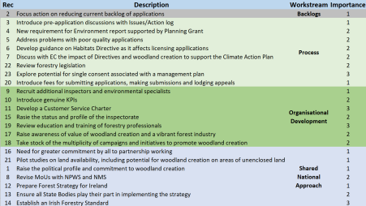*Table 2. Scope of work4*

Initial deliverables and milestones were suggested for each workstream which have been collaboratively refined by the groups. The Project Board will need to sign-off the firm deliverables and the timing of milestones based on resource availability (in DAFM and elsewhere).

OUT OF SCOPE

Several items/issues are noted in Annex 4 to the O’Hara report and deemed out of scope for Project Woodland.

2.3 FORESTRY POLICY GROUP (FPG)

The establishment of a Forestry Policy Group (FPG) addressed some previous limitations in cross-sectoral dialogue; Project Woodland’s work will set out a national vision and

4 Taken directly from the O’Hara Report. Recs 17 and 18 were moved to WG3 from WG2 following discussion with the Project Board

Page **6** of **30**

strategy that will help to increase trust with stakeholders and set the groundwork for the 2023 EU Forest Policy. The FPG is comprised of representatives from industry, environmental NGOs, community, farmers, and state agencies. Current members are:

| **Organisation** | **Nominee** |
| --- | --- |
| NPWS | Jenni Roche |
| EPA | Bernard Hyde |
| Teagasc | Nuala Ni Fhlatharta |
| Forest Industries Ireland (FII) | Mark McAuley |
| FII | Brian Murphy |
| FII | Peter O'Brien |
| FII | Marina Conway |
| Association of Farm and Forestry Contractors in Ireland | Michael Moroney |
| IFA | Vincent Nally |
| Coillte | Mark Carlin |
| Association of Irish Forestry Consultants | Dermot Houlihan |
| Agricultural Consultants Association | Andy Dunne |
| Irish Timber Growers Association | Donal Whelan |
| Pro Silva | Paddy Purser |
| None So Hardy Nurseries | Teige Ryan |
| Environmental Pillar | Andrew St Ledger |
| An Taisce | Elaine McGoff |
| SWAN | Mark Boyden |
| Irish Wildlife Trust | Pádraic Fogarty |
| Birdwatch Ireland | Oonagh Duggan |
| Woodlands of Ireland | Joe Gowran |
| Irish Rural Link | Seamus Boland |
| COFORD | Eugene Hendrick |
| Irish Forestry Owners | Nicholas Sweetman |
| Forest Owners Co-operative Society/Limerick/Tipperary Woodland Owners | Kathryn O’Donoghue |
| Stop Climate Chaos Coalition | Sadhbh O’Neill |

The FPG provides a forum for sector stakeholders to input on the achievement of commitments in the programme for government and to address the range of immediate challenges currently facing forestry in Ireland. This forum facilitates those stakeholders, state agencies, industry, community groups, farm bodies and NGOs working together and with DAFM to propose improvements to the current operation of forestry policy and input into the development of a new national forestry strategy.

FPG inputs are key to the work of Project Woodland as it moves forward with a vision and strategy for forestry in Ireland for 2022 and beyond. The FPG has opportunities to interact across the Project Woodland workgroups including licensing process improvements, elimination of system backlogs, organisational improvements and a customer-centric focus. It is to be expected that its engagement will deliver multi-functional benefits from an economic, social and environmental perspective; to contribute to wider Government and EU policy on climate, biodiversity, water quality, the rural economy and social and community engagement.

Page **7** of **30**

2.4 PROJECT OPERATING DEFINITION AND ASSUMPTIONS

Definitions

The term ‘project plan’ is defined to mean all *intended work and outputs of the Project Board, independent advisors and workgroups including schedules, activities, milestones and outputs*. The project plan is under ultimate control of the Project Board acting via the Project Sponsor (Colm Hayes Assistant-SG of DAFM) and the Project Manager. Project Sponsor will maintain sufficient resources to carry out the intended work of the project plan.

2. The Project Board and Workgroups agree the contents of this document as representing the overall definition of Project Woodland.

3. This Project Charter is a reference document that: (1) ensures that work being undertaken continues to meet project objectives, and (2) helps to resolves project issues— whether surfaced from within or by working groups, stakeholders including industry, DAFM, or any other.

4. O’Hara’s Recommendation 13 has been agreed—

“*A rapid overarching review of project progress should be undertaken within 6-8 months of initiation and advice provided to the Minister on any changes required to secure success*”.

Accordingly, a significant **stage gate review** will take place before the end of 2021 or soon thereafter.

5. DAFM resources remain available to serve as Subject Matter Experts (SMEs) and provide necessary information to support project requirements, technical information and any other materials that are necessary to project success. Additional full-time, dedicated resources will be identified including deployment of suitably experienced project and change management expertise to support the Project Manager5. It is also crucial to quantify what resource levels and timing are required to enable the outputs of the working group to be validated, and subsequently incorporated into organisational and operational models.

6. When and if DAFM provides the facility, workgroups will retain document drafts, agreed meeting notes/agendas/minutes in secure Shared Folders to be provided. This will enable collaborative drafting/editing with the possibility of restricted access where required. The

Project Board can have access to these folders or to selected parts thereof and should have its own secure document storage capability.

7. Workgroup Chairs and DAFM Leads will ensure timely delivery of Workgroup Status reports in a common format.

8. The complete list of tasks to be performed for each WG and for the Business Systems Analysis work will be defined in a separate project plan together with milestone dates, schedules/timelines and dates for significant reviews.

5 O’Hara §3:¶32

Page **8** of **30**

9. DAFM will resource the necessary tasks of coordinating communications with FPG, other forestry sector stakeholders, the public, state agencies, government departments, Oireachtas committees, unions and its own staff. The precise mode of communication and expectation of timing of updates will be determined by Project Sponsor in consultation with the Project Board.

10. Workgroups are responsible for assessing the completion of activities that support the delivery of milestones. Chairs will meet each other independently of their Workgroups to coordinate any appropriate joint responses and/or recommendations, co-dependencies and common actions. A view may be taken as to whether individual member(s) of Workgroups should attend meetings of other Workgroups by invitation.

11. Workgroups will each maintain a Risk Register and update it in line with the Workgroup Status Reports. This register will identify key project risks and evolve strategies to avoid/reduce them. Risk severity will be rated low (L), medium (M) or high (H) as in Table 1 below .

It should be noted that Risks may arise or abate at any time. Additional Risks may be Workgroup-specific and should also be identified and monitored in their Risk Register. It may be useful to categorize risk under standard headings such as (and there are others):

| **Category Severity Nature of Risk Possible Mitigations**  Scope L/M/H Endangerment of project  Ensure goals are concrete and minimize any  objectives, deliverables or  additional work. Create **Change Request** to  timeline  Board where scope may indicate change  Timeline L/M/H Not enough time to complete all  Continuously check tasks are scheduled  necessary tasks; poor  accurately and effectively; team needs to  identification of necessary tasks;  continually self-assess completion status  set of tasks not sufficient to  deliver to objectives  Resources L/M/H Not enough people allocated to  Check people have sufficient time to commit and  tasks  that items such as holiday leave and downtime  are monitored  Communicati  L/M/H Stakeholders unhappy, or  Communicate professionally upwards and  ons  unclear  outwards; also develop strategy to communicate  to industry/sector e.g. weekly bulletin  Procurement L/M/H Getting necessary additional  Check DAFM can procure necessary resources  resources or advisors in place on  on time; what actions are needed at DAFM?  time |
| --- |

*Table 1. Possible categories of risk*

Page **9** of **30**

3.0 ARRANGEMENT OF THE WORK

O’Hara structured MacKinnon’s recommendations into four streams of work for implementation, with priorities assigned.

The WGs have structured their recommended workstreams into activity schedules with outline timelines. These schedules will be approved by the Project Board and published separately from this Charter.

3.1 WORKGROUP TERMS OF REFERENCE, SCOPE, OBJECTIVES

The Workgroups operate in a collaborative framework with the Chair acting as facilitator/moderator. O’Hara states: “*This need for collaborative working cannot be over emphasised: the current situation cannot be addressed without constructive action from many stakeholders*”.

Terms of Reference were developed by the WGs and approved by the Project Board based on the Scope, Objectives and Recommendations in O’Hara. These may be subject to amendment as required – this could arise due to change arising from third party advice for example and may be needed to expand or limit scope.

Table 3 below lays out the Scope, Objectives and Principal Outputs for each workgroup keyed to O’Hara’s recommendations in Table 2. Milestones were determined and refined by each WG using the original suggestions in O’Hara. The PB will monitor success in achieving these milestones. Completion of supporting tasks is self-assessed by WGs. Regular Project Manager attendance at WG meetings will monitor and report completion status, likelihood of achieving milestones, risks, corrective actions required and blockages encountered during any reporting period.

| WG1  Backlog  Rec.2 | **Scope:** addresses a single recommendation (Rec 2). It co vers all applicationsfor licences (roads, afforestation and felling) that have been in the system longer than agreed  target processing times. A clear definition of ‘backlog’ will be recommended by the group.  **Objectives**: reduce the current backlogs of licence applications for Affor estation, Roads, Felling and Thinning. Achieving this objective further re quires the group to:  • agree and publish a definition of “Backlog”  • propose early warning indicators such that any future backlog can be identified and managed expeditiously  • liaise with WG4 as to (a) the business process review being un dertaken, and (b) regulatory/legal review on the 15Km issue and other matters including possible ‘quick wins’  • engage with Business Systems Analysis work  **Principal Outputs:**  • Targets for backlog to be agreed and incorporated into the Cus tomer Charter (WS3). This includes consideration of how to seg regate real backlog from batch applications for scheduled future processing |
| --- | --- |

Page **10** of **30**

|  | • Published process for reducing the backlog to achieve the tar gets including prioritisation and scheduling  • Monthly publication of the number, type and area of applica tions within the backlog against target trajectory |
| --- | --- |
| WG2  Shared Approach  Recs.  16,21,1,8,12,13,  14 | **Scope**: WG2 covers 9 of the O’Hara recommendations in respect of de veloping a national view of what Ireland wants from trees, wood and for ests. Imperatives are to increase tree cover, produce wood-based prod ucts, inform government policy and bring stakeholders together. The rel evant recommendations are to:  • Raise the political profile and commitment to woodland creation • Revise MoUs with NPWS and NMS  • Prepare a Forestry Strategy for Ireland  • Ensure all State Bodies play their part in implementing the Strat egy  • Establish an Irish Forestry Standard  • Need for greater commitment by all to partnership working • Raise awareness of value of woodland creation and a vibrant for est industry  • Take stock of the multiplicity of campaigns and initiatives to pro mote woodland creation  • Pilot studies on land availability, including the potential for woodland creation on areas of unenclosed land  **Objectives:**  • Establish a cross-society vision of the role of trees, woods and forests in Ireland’s future – including social, environmental and economic outcomes in alignment with the UN’s sustainable de velopment goals and the EU Green Recovery Plan.  • Align the actions of key public organisations to the delivery of the vision  • Build and support a coalition of stakeholders to support, cham pion and promote delivery of shared forestry objectives  • Establish a shared, objective assessment of the suitability and availability of land for a range of different types of forestry across Ireland.  **Principal Outputs:**  • Forestry Strategy  • Refreshed Irish Forest Standard and associated documents • Updated terms of reference for the Forestry Policy Group re flecting other changes, including a forward agenda |
| WG3  Organisational  Development  Recs. 9,10,11,15, 17,18,19  (Note: 17 and 18  were originally  assigned to WG2) | **Scope:** WG3 covers 5 of the O’Hara recommendations in respect of im proving proactive leadership and providing a responsive customer-ser vice ethos via a new Customer Charter. The relevant recommendations are to:  • Recruit additional inspectors and environmental specialists • Introduce genuine KPIs  • Develop a Customer Service Charter  • Raise the status and profile of the inspectorate  • Review Education and training of forestry professionals |

Page **11** of **30**

|  | **Objectives**: ensure that future staff, structures, customer focus and sys tems of the forestry teams within the Department are fit for purpose and:  • ensure that the Department, COFORD, Teagasc and Coillte work better collectively for the development, promotion, regulation and delivery of forestry policies  • draft a new/revised Customer Charter  • conduct a Training Needs Analysis  • draft a Communications & Promotion Strategy  • consider impacts of team morale, cultural values and iden tity as part of the development strategy  • draft the terms of reference for independent organisational capabilities consultants  • agree an approach to communicating with stakeholders and promoting sustainable forestry  • raise awareness of value of woodland creation  • take stock of multiplicity of campaigns  **Principal Outputs:**  • Renewed organisational structure, job descriptions and ca pability review for all DAFM forestry teams  • Customer charter  • Set of KPI’s and associated targets  • New suite of training courses (ideally run jointly between DAFM and others)  • Website / web-pages to explain the landscape of forestry bodies in Ireland  • Refreshed mandate and profile for Coford  • Communications programme for Forestry in Ireland |
| --- | --- |
| WG4  Process  Recs.  3,4,5,6,7,22,23,30 | **Scope:** There are 7 O’Hara recommendations for consideration by WG4. These aim to improve efficiency and effectiveness of processes to deliver better results while addressing legal and regulatory requirements. Achieving the overall objective will require action by applicants and their representatives as well as by DAFM to drive out poor practice (e.g. inap propriate ‘cut and paste’ applications) and speculative applications which are the source of considerable inefficiency in the system.  **Objectives:**  WG4 has two key objectives: (a) improve efficiency and effectiveness of the licence process, and (b) improve the quality of applications at the front-end of the process. Work will focus on:  • recommendations for pre-application consultation  • proposed environment report with associated grant  • end-to-end process review of the licensing system. This may lead to recommendations for appropriate transformation of administrative and technology aspects  • establish if a single licence consent is feasible  • ensure adherence to regulatory standards  • independent regulatory review |

Page **12** of **30**

|  | **Principal Outputs:**  • Clear explanation of the statutory basis for forestry regula tion process  • Pre-application meetings and Issues Log process  • Updated licensing process  • Pilot of environmental report process and recommendation for where this should be used, alongside grant support  • Training courses established for DAFM staff, prescribed bod ies and registered foresters to embed new processes for pre application meetings, issues log and environmental report  • Feasibility and cost-benefit study into single application pro cess  • Improved processes for registered foresters to keep abreast of changing environmental regulations |
| --- | --- |

*Table 3. Scope, Objectives, Deliverables*

3.2 BUSINESS SYSTEMS ANALYSIS & PROCESS

The process review/analysis activities commenced during June 2021. Much of the work on Project Woodland depends upon both the output of this process review and its recommendations for appropriate improvements. Furthermore, the process review work needs to interact in parallel with a legal/regulatory review as it moves towards recommending possible system change later in 2021s.

The process review will make best efforts to highlight possible “quick wins” where temporary improvements and optimisations may be feasible. It will consider both ICT and administrative systems/processes and look to serial processes that might better be done in parallel. The implications for importing ICT technology with document management capabilities will be considered.

There may be opportunities for DAFM to augment its IFORIS system with machine learning (AI) technologies, and/or operations modelling/optimisation, to speed up and improve the overall process. For example, Insight SFI Centre for Data Analytics is already in significant collaborations with Teagasc, DAFM, and the recently announced VistaMilk SFI Research Centre. Document Management systems may also be considered.

Refer to Appendix 4 for details of the Business Systems Analysis plan.

3.3 INDEPENDENT REVIEWS – IRELAND, EU AND EUROPE

DAFM will procure the services of independent expert consultant(s) to provide:

• an analysis of the basis for the 15km appropriate assessment radius and recommend whether this criterion should be substituted by alternative criteria capable of better reflecting the specific circumstances applicable in each case (subject to and supplemented by legal and regulatory advice). WG1 is taking a specific lead on this and it is also relevant to other groups. It is critical to the delivery of milestones later in 2021 that this review commence at the earliest and be carried out expeditiously

• comparative licensing processes in an agreed sample of EU/European countries with forward-looking legal and regulatory context. These form a significant part of the WG4 workstream to ensure that emergent processes will be fully compliant

Page **13** of **30**

• organisational design/development expertise for WG3 and a capability review (following development of a new Forestry Strategy by WG2).

Appointment, terms of reference and scope of each review component shall be agreed by the Project Board in conjunction with DAFM.

4.0 PROJECT COMMUNICATIONS AND REPORTING

There is a significant requirement on a project of this magnitude and importance to have a coherent communications and promotion strategy directed at providing timely and appro priate information. Such information will include project progress, future plans, general feedback, issues of national significance and specific barriers to success. Such information will be delivered to:

• Ministers

• DAFM staff

• Communities and the public

• Sector stakeholders

• Training agencies

• NGOs & state agencies

• Ecology- and environment-related groups

The following project communications comprise the normal flow of project management in formation within Project Woodland.

| Type | Fre  quency | Prepared by | Circulated/Attended |
| --- | --- | --- | --- |
| 1. WG Status Reports | Monthly | WG Secretariat, DAFM Lead, WG Chair | PM, Shared Folders, WG members |
| 2. Public Update  (Web) | Monthly | TBD | WWW |
| 2. Business Analysis Report | Weekly | Business Analyst | PM, WG4/1 Chairs |
| 3. Project Status Re ports | Monthly | PM | Sponsor, Project  Board, WG Chairs |
| 4. Licencing Dash  boards | Weekly | Forestry | Stakeholders, ++ |
| 5. HOD Meeting | Weekly  (Mon) | - | Sponsor, PM, HOD |
| 6. Ecology End-of  Week | Weekly  (Fri) | DAFM & Commercial ecology | PM, Ecology, BA, Sponsor |
| 7. Ecology Main Up date | Weekly  (Tue) | DAFM & Commercial ecology | PM, Ecology, BA, Sponsor |
| 8. ASG Update | Weekly  (Mon) | EOD/SOC | ASG, EOD, SOC |
| 9. FPG Update | Bi  Monthly | Specific update to FPG | FPG |

*Table 4. Project Communications*

Page **14** of **30**

5.0 GOVERNANCE

5.1 ROLE OF THE PROJECT BOARD

The role of the board is to oversee delivery of the project:

• Championing the project and raising awareness at senior level

• Approving strategies, delivery plan, project scope and milestones

• Support the project manager and securing resources

• Resolving strategic and policy issues and responding to major issues • Driving and managing change through the organisation

• Prioritising project goals with other ongoing projects.

• Communicating with other key organisational representatives

• Overseeing risk and mitigation processes

5.2 ORGANISATION OF WORKGROUPS

Each should have a named Chair and a DAFM Lead responsible for delivering the agreed tasks and outputs and for reporting progress and issues to the Project Manager through a Secretariat. A set of agreed deliverables and milestones will be produced and com bined into an overall project milestone plan to track progress with implementation. The cross-sector working groups for each workstream will form a vital basis for ensuring ro bust solutions with broad-based buy-in. This will include technical and customer experts drawn from the FPG members who can work with DAFM staff to develop and stress-test proposals and deliverables.

5.3 ROLE OF THE SPONSOR AND PROJECT MANAGER

The Project Sponsor exercises executive authority within DAFM to carry out agreed actions on behalf of both the Secretary-General and Project Board. The Sponsor is first point of contact for the Project Manager.

The Project Manager has responsibility for co-ordinating the delivery of the project, advising the Sponsor on allocating resources and monitoring risk management. The Project Manager is also responsible for overall co-ordination of internal and external communications.

Both the Project Manager and Sponsor work closely together to monitor progress against plans for each Working group and to ensure that all participants in Project Woodland including the FPG are kept closely informed on progress. Where blockages to progress are identified the Project Manager will address strategies to mitigate those blockages and agree with the Sponsor and Project Board how best to action those strategies.

5.4 GOVERNANCE—PROJECT ORGANISATION

The organisation of Project Woodland is indicated in Fig 2 below (subject to possible change from time to time). DAFM retains executive powers and responsibilities on behalf of the Minister and cannot delegate those powers to non-DAFM participants, nor to the workgroups in Project Woodland.

Page **15** of **30**

It is a function of the Project Board to provide advice, challenge proposals and make recommendations to the Minister. The workgroups act in a consultative and advisory capacity to the Project Board by researching, analysing and making informed proposals.

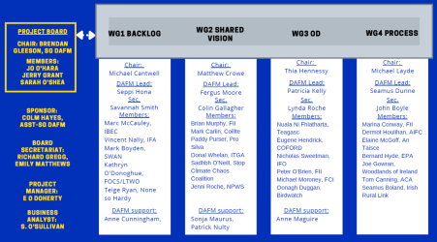***Fig 2. Personnel on Project Board, Workgroups & additional DAFM support***

Page **16** of **30**

**5.4.1 GOVERNANCE STRUCTURE**

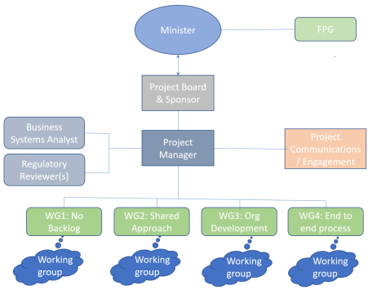

The Project Board and Sponsor act on behalf of the Minister to drive Project Woodlands forward through the Project Manager. The next sections deal with the overall roles and responsibilities.

5.5 GOVERNANCE—PROJECT BOARD STANDARD OPERATING PROCEDURES

The Project Board, as shown above in Fig 2, oversees delivery of the project, is responsible for the overall direction of the four workgroups and has overall responsibility for accepting/amending/rejecting recommendations intended for the Minister whether as formal or informal submissions.

It is the first point of escalation of critical risks and issues and Change Control requests (see section below). It ensures that project teams meet their objectives and monitors completion of milestones, KPIs for Backlog reduction and final project outcomes. The Board ensures that the project remains focused on achieving its projected benefits.

The Project Board will have roughly monthly project meetings, supplemented by field visits and issue-specific discussions as necessary’

Page **17** of **30**

**Workgroup overlaps and dependencies**

There are strong dependencies between groups. The Board will consider the details of proposals from groups in order to address overlaps, dependencies and constraints to action. The Board may request groups to make joint proposals to avoid duplication of work.

**Composition**

The members of the board are:

• Chair: Brendan Gleeson holds executive responsibility as Secretary-General, DAFM

• Jo O’Hara – non-executive

• Sarah O’Shea – non-executive

• Jerry Grant – non-executive

**Meeting protocols**

Meetings will be arranged by the Secretariat to the Project Board who will send out establish the timetable of meetings well in advance and send out invitations on behalf of the Chair.

Specific working Group Members and/or stakeholders may be invited to attend/observe all or part of any meeting. The Project Manager and Project Sponsor will be expected to attend Project Board meetings.

**Secretariat**

Secretariat support to the Project Board will be provided by DAFM and will arrange the meeting agenda and circulate minutes, documents and/or links to shared documents.

**Quorum**

Members of the Board are expected to be in attendance (in person or web conference) if formal decisions are to be taken at a meeting. Non-voting attendance of Sponsor, PM or any other person(s) is at the discretion of the Board.

The quorum for meetings shall be three members of the Board including the Chair where the fourth member cannot be reached by correspondence for a decision. Meetings can take place in person or via conference (web conference or phone).

The Board has discretion to decide what matters are of such importance that a formal decision must be communicated to an absent member.

Notwithstanding the quorum of three any formal decisions must be put to all members of the Board wither when the full Board is present or via email to those members absent from the meeting before being signed off by the Board.

Page **18** of **30**

**Document Management**

The Board understands that DAFM will proceed to set up a system for shared document editing and management. Details of the procedures around this facility will be circulated when available. The key principles are to (a) ensure that single, secure copies of draft documents are available to relevant collaborators, (b) retain final versions of all project outputs, and (c) manage access to documents applying appropriate security credentials.

The Secretariat to the Project Board will arrange secure management of Board documents and correspondence.

**Submissions from Workgroups**

All submissions to the Project Board will be routed through the Secretariat. The nature, mechanism, form and timeliness of responses to any such recommendations will be decided by the Board. Papers should clearly indicate to the Board whether they are for decision, discussion or for information. Only decision and discussion papers will receive a formal response. Where the board is being asked for a decision, clear recommendations with some analysis of alternatives should be provided.

The Project Board shall review and consider all submissions and seek additional information or advices as it deems appropriate. The Project Board will advise the Chair of each WG as to the outcome of its considerations which may include, but which is not limited to, feedback on recommendations, suggested approaches, next steps or further proposals for the WG to consider. The Project Board shall also seek advice and/or guidance from third parties where necessary, including but not limited to, DAFM, individuals, independent advisors or other third parties when making its considerations Criteria for consideration will be (a) compliance (based on advice), (b) ability to implement, and (c) overall contribution to efficiency and robustness of the process.

The Project Board will consider submissions/recommendations in the round and seek to agree a delivery timeframe with DAFM.

At minimum, to facilitate decision-taking, submissions and/or recommendations should include (a) a statement of the background to each item, (b) a formal proposal to the Board, (c) recommended timescales for implementation, (d) recommended timescale for decision(s), and (d) any additional supporting commentary including any necessary resources needed. Where a decision is required, the paper should include clear recommendations with some analysis of alternatives.

The Board will seek to understand the breadth of views within each working group, therefore WG Chairs are tasked to note any substantial alternative views expressed within the group.

**Agenda and Minutes**

The agenda for Board meetings will include the following items as standard (agreed actions to be minuted):

1. Consideration of prior minutes

2. WG Status updates & KPIs

Page **19** of **30**

3. Items for Consideration/Decision (and communication via WG Chairs to groups) 4. Items for Discussion

5. Items for Information only (supplementary documents not necessarily for discussion) 6. Review of agreed Board member actions & responsibilities

7. AOB

The minutes shall be a record of the overall discussion which took place at the Board meeting and not a verbatim record. The minutes shall record the topic discussed, note the broad discussion which took place, the decisions made, any follow up actions to be taken, the responsibility for such actions and where appropriate a timeline for such actions. Comments and contributions made by individual Board members do not have to be recorded unless requested by the Board member to do so. The Board shall be entitled to query the minutes prepared, make suggested amendments and where any question arises as the accuracy of the minutes the Board may determine such matter by majority vote with the Chair having any final vote on the matter.

**Decisions**

Decisions shall be made by consensus where possible and every effort shall be made to achieve a consensus. Where a consensus is not possible a majority vote shall be taken and it shall be noted in the minutes that such decision was not unanimous. In the event of an equal number of votes the Chair of the Board shall have a second casting vote .

**External experts**

DAFM will have contractual responsibility for any and all External Experts recruited to Project Woodland. The Board through the Sponsor, PM and Workgroup Chairs will provide advice and guidance. The Project Manager will review plans, schedules and tasks and monitor the activities of any such external experts. This may include experts in the area of ecology, planning, legal/statutory/regulatory reviews which impact the workgroups.

The Board will approve overall Terms of Reference, scope and deliverables for such experts and DAFM shall manage the details of the contracting process and agreed reporting lines.

**Communications and Promotions strategy**

The Project Board will oversee a multi-stage communications strategy, spearheaded by WG3. This aims to build consensus that the strategy targets each of the objectives Eco nomic, Social/Amenity, Climate, Biodiversity. There is a need to build a shared national un derstanding on the environmental impacts of woodland, and how good management mini mises issues like runoff, fertiliser and pesticide and herbicide use.

This strategy will operate with suitability factors and constraints - forging agreement on the general criteria for where woodland can/cannot be situated. There are opportunities to reach out to agencies, research organisations and construction businesses regarding the case for softwoods which are the core material for the building industry while at the same time delivering the most significant carbon sequestration benefits.

The Project Board will issue Interim Reports approximately calendar quarterly, the first re port due in July 2021.

Page **20** of **30**

5.6 GOVERNANCE—WORKING GROUP STANDARD OPERATING PROCEDURES **Meeting protocols**

Meetings will be arranged by the Secretariat of each workgroup who will send out invitations on behalf of the Chair. Each WG Secretary should discuss admin/organisational aspects for the group with the Chair and relevant DAFM lead and the support AP or as appropriate. Any requests for information from group members and/or the Chair should also be shared with the DAFM lead and the support AP /GR1. The DAFM lead, Group Secretary, and support AP/GR1 form the Secretariat of the Working Group.

Working Group Members and the Project Manager should be invited. The DAFM lead is the only DAFM member of the Working Group. Other DAFM personnel and the Project Manager are treated as observing. The group Secretariat should attend meetings and take minutes.

DAFM support personnel (and also the Business Systems Analyst), who have been identified to provide input into these groups, will not necessarily attend each meeting. The Chair will decide in consultation with the DAFM Lead who should go to any meeting as the Work Programme develops, and whether external experts should be invited.

**Document repository**

The Board understands that DAFM will proceed to set up a system for shared document editing and management. Details of the procedures around this facility will be circulated when available. The key principles are to (a) ensure that single, secure copies of draft documents are available to relevant collaborators, (b) retain final versions of all project outputs, and (c) manage access to documents applying appropriate security credentials.

The Secretariat to the Project Board will arrange secure management of Board documents and correspondence.

**Conduct of meetings**

All questions and comments will be put through the WG Chair who will ensure a proper record is kept for the meeting minutes. Confidentiality of WG discussions is to be assured under Chatham House principles. Conversations can be reported with agreement of the group but not attributed to individuals.

**Agenda and Minutes**

A Meeting Agenda will be distributed by the Secretariat in advance of each meeting together with prior meeting minutes. The first item in the agenda should be a review of minutes/notes and action items from the prior meeting. A formal agenda for WG meetings will include the following items (agreed actions to be minuted):

1. Consideration of prior minutes (optionally by common assent)

2. WG Status update & KPIs - evaluation of progress against milestones and outputs 3. Items for Consideration/Decision

4. Items for Discussion

Page **21** of **30**

5. Items for Information only

6. Review of agreed Actions & Responsibilities

7. AOB

The minutes shall be a record of the overall discussion which took place at the meeting and not a verbatim record. The minutes shall record the topic discussed, note the broad discus sion which took place, the decisions made, any follow up actions to be taken, the responsi

bility for such actions and where appropriate a timeline for such actions. Comments and contributions made by individual members do not have to be recorded unless requested by the member to do so. The members of the WG shall be entitled to query the minutes pre pared, make suggested amendments and where any question arises as the accuracy of the minutes the WG may determine such matter by majority vote with the Chair having any final vote on the matter.

**Decisions**

Decisions shall be made by consensus where possible and every effort shall be made to achieve a consensus. Where a consensus is not possible a majority vote shall be taken and it shall be noted in the minutes that such decision was not unanimous.

**Meeting Chair**

The WG Chair is responsible for facilitating and chairing the meeting to ensure that the Working Group’s objectives are met. They ensure that the meeting starts and ends on time and that any presenters adhere to allocated time frames. They also ensure that members are each given fair time in discussion and that dissenting voices are noted.

**Secretariat**

The Secretariat is responsible for documenting the status of all meeting items and taking notes of anything else of importance during the meeting. The Secretariat, DAFM Lead and the Chair will agree the minutes following the end of the meeting.

**Recommendations and submissions to the Board**

Submissions to the Project Board will be routed through the Secretariat. The nature, mechanism, form and timeliness of responses to any such recommendations will be decided by the Board. Papers should clearly indicate to the Board whether they are for decision, discussion or for information. Only decision and discussion papers will receive a formal response. Where the board is being asked for a decision, clear recommendations with some analysis of alternatives should be provided.

The Project Board intends to review and consider all submissions and seek additional information or advices as it deems appropriate. The Project Board will advise the Chair of each WG as to the outcome of its considerations which may include, but which is not limited to, feedback on recommendations, suggested approaches, next steps or further proposals for the WG to consider. The Project Board shall also seek advice and/or guidance from third parties where necessary, including but not limited to, DAFM, individuals, independent advisors or other third parties when making its considerations Criteria for consideration will be (a) compliance (based on advice), (b) ability to implement, and (c) overall contribution to efficiency and robustness of the process.

Page **22** of **30**

The Project Board will consider submissions/recommendations in the round and seek to agree a delivery timeframe with DAFM.

At minimum, to facilitate decision-taking, submissions and/or recommendations should include (a) a statement of the background to each item, (b) a formal proposal to the Board, (c) recommended timescales for implementation, (d) recommended timescale for decision(s), and (d) any additional supporting commentary including any necessary resources needed. Where a decision is required, the paper should include clear recommendations with some analysis of alternatives.

The Board will seek to understand the breadth of views within each working group, therefore WG Chairs are tasked to note any substantial alternative views expressed within the group.

The Chair will coordinate the drafting of submissions to the Board and seek consensus from the WG. In the event of disagreements arising as to content or form of submission, the Chair will note matters agreed by consensus, matters agreed by majority after debate, and matters where no agreement was found.

Subsequent responses from the Project Board to the Chair shall be brought to the attention of the WG at the earliest opportunity.

Page **23** of **30**

6.0 CHANGE CONTROL PROCESS

In the course of implementing Project Woodland, new information may emerge or there may be changes in requirements or in the substantive environment. Such changes may indicate amendments to project scope and consequent levels of effort, timelines or workable solutions.

Any proposed changes to project scope require a Change Request Notification, which will take the form of a submission by one or more workgroup Chairs to the Board including justifications for the proposed change and supporting information. The Board will consider any such Change Control Notification in the context of the project as a whole as a matter of urgency.

Any such submission should be routed through the Project Board Secretariat.

Page **24** of **30**

APPENDICES

1. OVERALL STATUS REPORT

This report will be prepared by the Project Manager and filed in the appropriate Shared Folder. It summarises the status of the four WGs each month and intended to be communicated monthly to both the Sponsor and Project Board. All of the WGs also have an interest in this information. Here is an example (not necessarily complete):

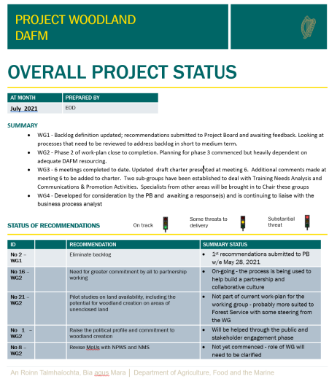Page **25** of **30**

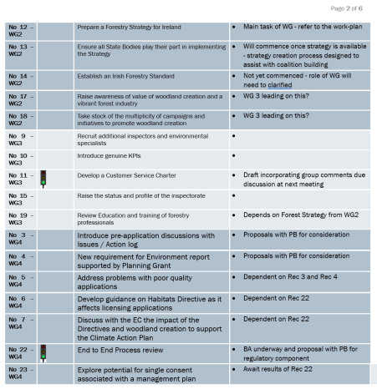Page **26** of **30**

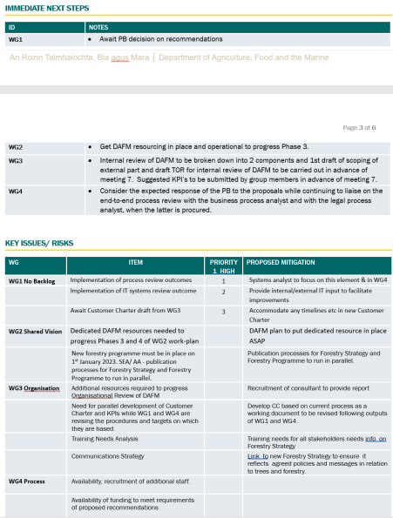Page **27** of **30**

**The actual report will have one Actions Status sheet (see below) per Workgroup. Only one is included below. The rightmost Notes column refers to the text at bottom of sheet.**

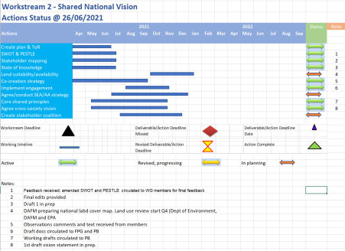Page **28** of **30**

2. WORKGROUP STATUS REPORT

This report will be prepared monthly by the secretariat of each WG and submitted following each WG meeting to the Project Manager. It summarises the status of a WG and is intended to be a record of WG status communicate principally for the Project Manager. All of the WGs also have an interest in this information. Here is the sample template used for local project and risk management purposes.

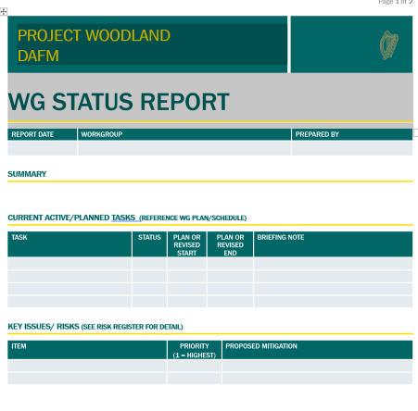Page **29** of **30**

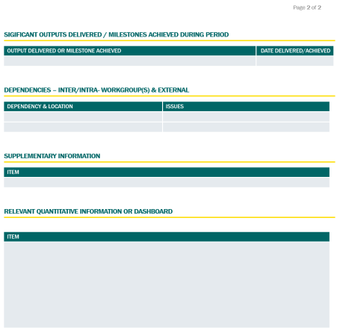Page **30** of **30**